How to Use PHPUnit
- Installing PHPUnit

- Install XAMPP, WAMP, or any PHPWEBSERVER
- Open Command Prompt (⊞ Win+R opens the Run dialog box. Type CMD)
- Change to PHP Directory (eg: C:/Xampp/php)
- Run Command to install PHPUnit with Pear
- pear config-set auto_discover 1
- pear install pear.phpunit.de/PHPUnit

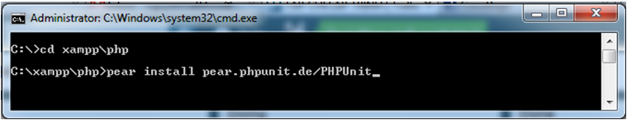
- Install PHPUnit_Selenium
- pear install phpunit/PHPUnit_Selenium
- Install PHPUnit_SkeletonGenerator
- pear install phpunit/PHPUnit_SkeletonGenerator
- 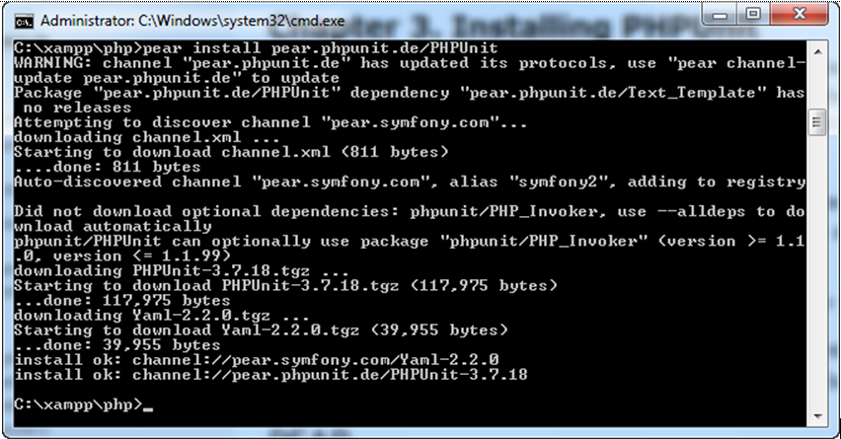

- PHPUnit with NetBeans

  - Installing PHPUnit for NetBeans

Open Plugins in Netbeans

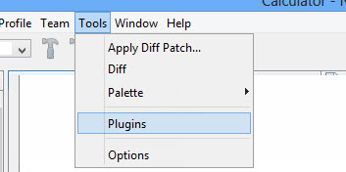

Install plugins:
      - PHP
      - Selenium Module for PHP
      - PHP Documentor Tag Help
      - PHP Documentor

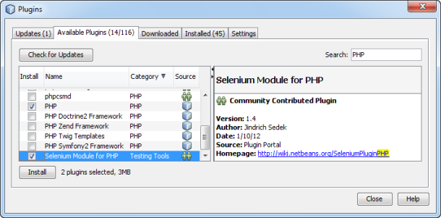
  - Config Netbeans Options

Netbeans > Tools > Options > tab: PHP

Open the Unit Testing tab. The paths to your PHPUnit and Skeleton Generator scripts should appear.

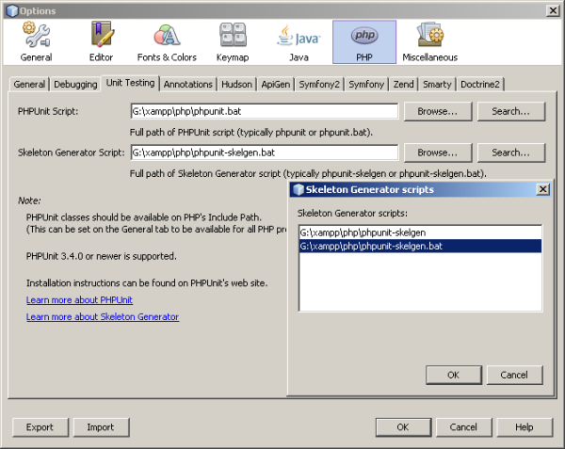

  - Create PHPUnit

Create a PHP project named Calculator. In this project, create a file named calculator.php. In this file, type or paste the Calculator class

<?php

class Calculator {

public function add($a, $b) {

return $a + $b;

}

}

?>

Add a comment block with the @assert annotation and some sample input and output. Note that one incorrect assertion is included in this example.

[…]

class Calculator

{

/**

* @assert (0, 0) == 0

* @assert (0, 1) == 1

* @assert (1, 0) == 1

* @assert (1, 1) == 2

* @assert (1, 2) == 4

*/

public function add($a, $b)

[…]

Note: You can use annotation code completion to add @assert annotations. Navigate between parameters with the Tab key, or click Enter after filling in a parameter value.

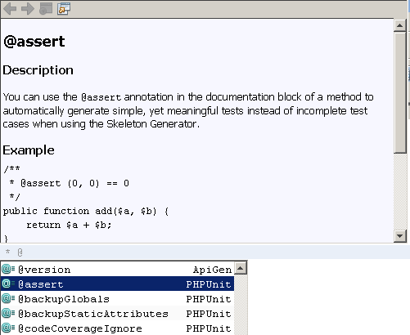

- In the Projects window
- Right-click the Calculator.php node
- select Tools > Create PHPUnit Tests.

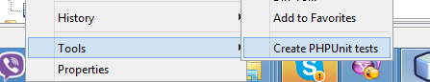
- The first time you create tests, a dialog opens asking you for the directory in which you want to store test files. In this example, the Browse function was used to create a tests directory.

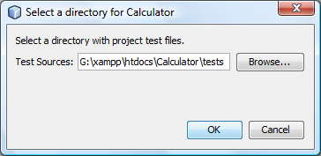
- The IDE generates a skeleton test class in a file called CalculatorTest.php
- Which appears in your Projects window and opens in the editor.
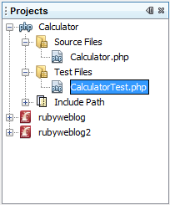 | /**  * Generated from @assert (1, 1) == 2.  */  public function testAdd4()  {  $this->assertEquals(  2,  $this->object->add(1, 1)  );  }
  - Run PHPUnit

To test the project, right-click the project's parent node and select Test, or press Alt-F6. To test the Calculator.php file, right-clict the file's node and select Test, or press Ctrl-F6.
The IDE runs the tests and displays the results in the Test Results window.
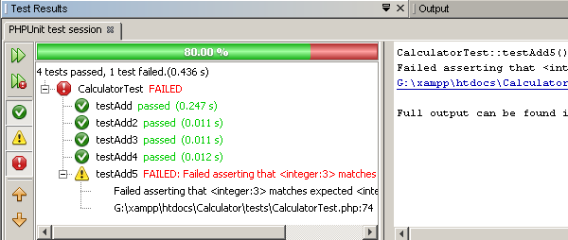
A more verbose textual version of the results is displayed in the Output window.

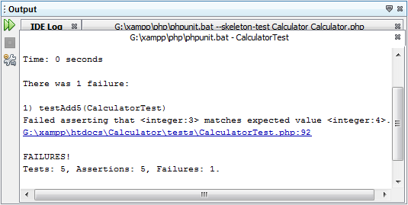

Run PHPUnit with Command-Line Test Runner
- Open command line and type
- C:\> phpunit UnitTest path/file.php

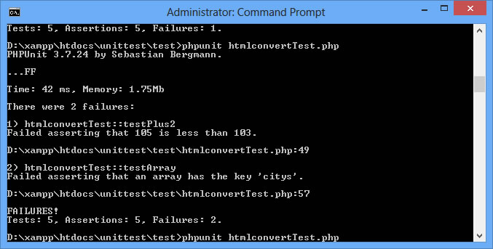
  - Using Test Groups

To create and run test groups:
In the Projects window, right-click the Project node and select Properties.
Select the PhpUnit category. Select Ask for Test Groups Before Running Tests. Click OK.

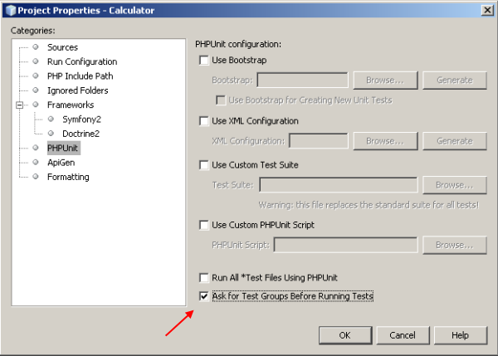
- Open CalculatorTest.php in the editor.
- For the methods testAdd, testAdd3 and testAdd5, add the annotation @group production.
- For the methods testAdd2 and testAdd4, add the annotations @group production and @group development

Code showing test group annotation
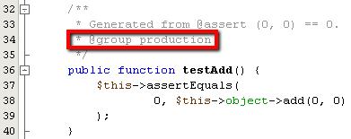 | 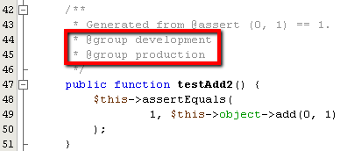
- Right-click the Calculator.php node and select Test. A dialog opens, asking you which test groups to run. Select "development" and click OK. The IDE only runs the tests that are annotated with @group development.

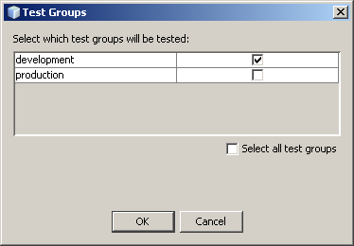
  - Test Results and IDE Output
        - In the Test Results window, you get information about failed tests from these locations:
        - Messages in the UI pane attached to the tree entry for the failed test
        - Text in the right-side pane, including links to the lines of test code that failed
        - Tooltip text that appears when you hover the cursor over a failed test in the UI pane

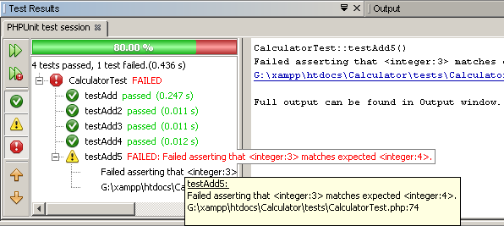
The Test Results window includes the following buttons on the left side:
- Rerun the test
- Show failed tests
- Show passed tests
- Show tests that passed but with errors
- Navigate between showing the next test result or the previous test result
  - Code Coverage

Open Calculator.php and add a duplicate add function, called add2. The Calculator class now looks like the following:

[…]

public function add($a, $b) {

return $a + $b;

}

public function add2($a, $b) {

return $a + $b;

}

[…]
- Right-click the project node. From the context menu, select Code Coverage > Collect and Display Code Coverage. By default, Show Editor Bar is also selected.

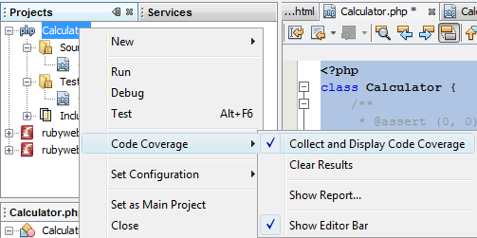
- Click Test to test the open file or All Tests to run all tests for the project.
- Covered code is highlighted in green and uncovered code is highlighted in red

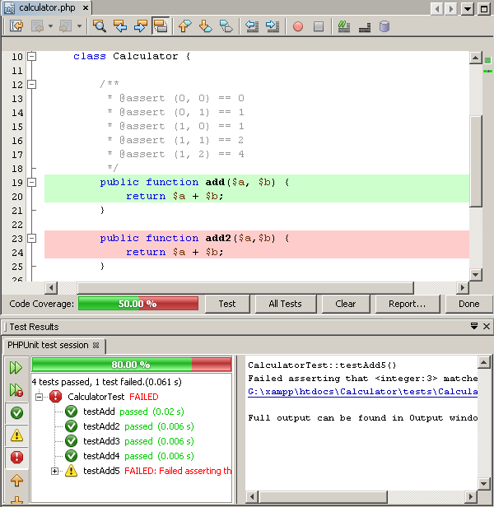

- To open Code Coverage report In the Editor Bar, click on Report.
- Code Coverage report showing the results of all tests run on your project:

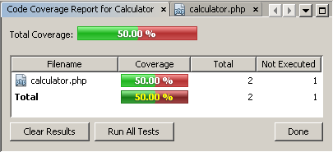

  - DRFGDFH

- PHPUNIT Assertions
This section lists the various assertion methods that are available.
- assertArrayHasKey(mixed $key, array $array[, string $message = ''])

Reports an error identified by $message if $array does not have the $key.
- assertClassHasAttribute($attributeName, string $className[, string $message = ''])

Reports an error identified by $message if $className::attributeName does not exist.
- assertContains(mixed $needle, Iterator|array $haystack[, string $message = ''])

Reports an error identified by $message if $needle is not an element of $haystack.
- assertEquals(mixed $expected, mixed $actual[, string $message = ''])

Reports an error identified by $message if the two variables $expected and $actual are not equal.
- assertSame

(mixed $expected, mixed $actual[, string $message = ''])

Reports an error identified by $message if the two variables $expected and $actual do not have the same type and value.
- assertGreaterThan

(mixed $expected, mixed $actual[, string $message = ''])

Reports an error identified by $message if the value of $actual is not greater than the value of $expected.
- assertClassHasStaticAttribute()
- assertContainsOnly()
- assertContainsOnlyInstancesOf()
- assertCount()
- assertEmpty()
- assertEqualXMLStructure()
- assertFalse()
- assertFileEquals()
- assertFileExists()
- assertGreaterThan()
- assertGreaterThanOrEqual()
- assertInstanceOf()
- assertInternalType()
- assertJsonFileEqualsJsonFile()
- assertJsonStringEqualsJsonFile()
- assertJsonStringEqualsJsonString()
- assertLessThan()
- assertLessThanOrEqual()
- assertNull()
- assertObjectHasAttribute()
- assertRegExp()
- assertStringMatchesFormat()
- assertStringMatchesFormatFile()
- assertSame()
- assertSelectCount()
- assertSelectEquals()
- assertSelectRegExp()
- assertStringEndsWith()
- assertStringEqualsFile()
- assertStringStartsWith()
- assertTag()
- assertThat()
- assertTrue()
- assertXmlFileEqualsXmlFile()
- assertXmlStringEqualsXmlFile()
- assertXmlStringEqualsXmlString()

For more information of Assertions visit: http://phpunit.de/manual/current/en/writing-tests-for-phpunit.html#writing-tests-for-phpunit.assertions

